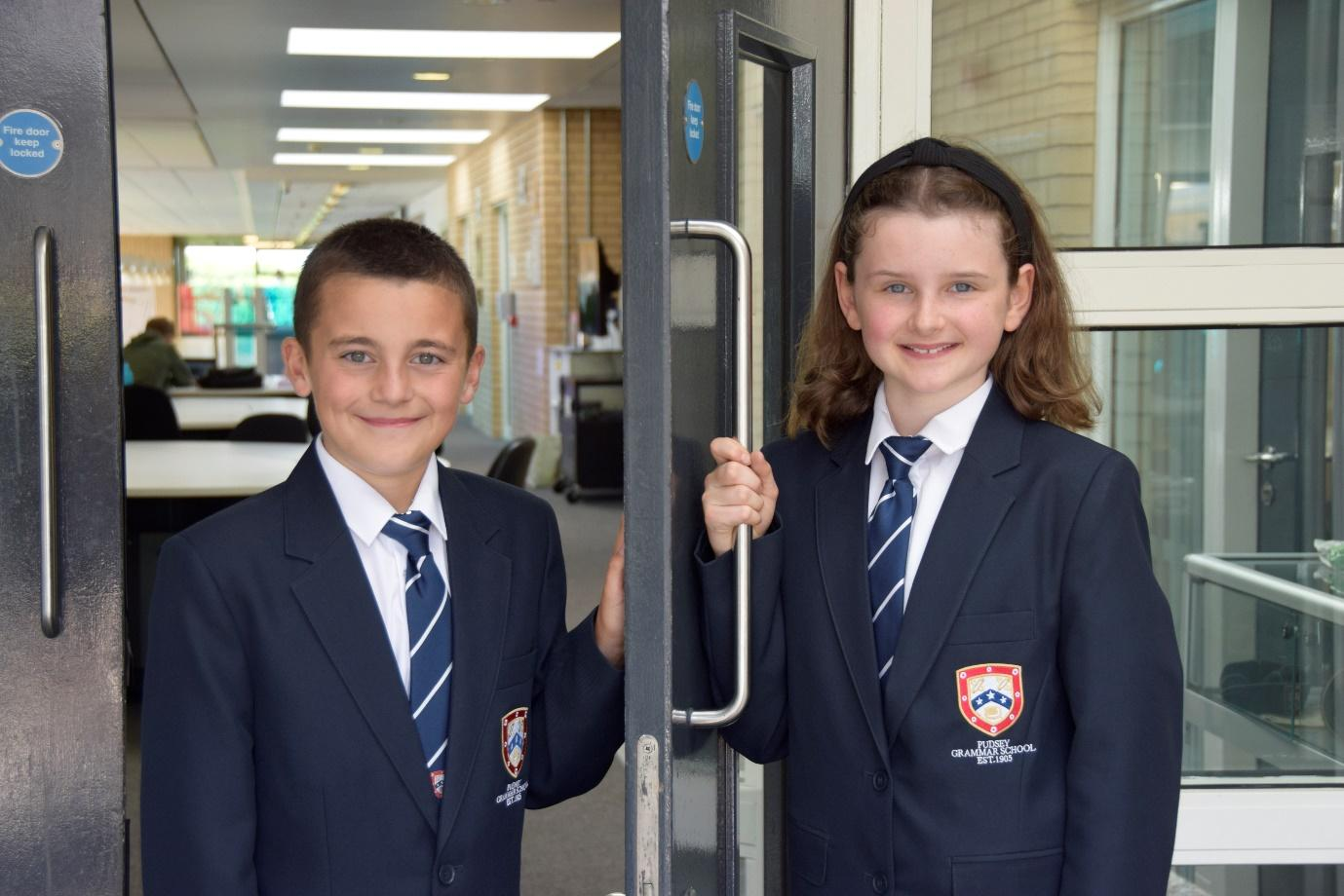

**TEACHER OF**

**ENGLISH**

**APPLICATION PACK**

**SEMH Mentor**

**C3 £27,852 - £29,439 FTE**

**(actual salary £24,203 - £26,041)**

**37 hours per week only plus 5 days**

**Working pattern to be confirmed (the school operates an early finish on Fridays from September 2024)**

**Start: As soon as possible**

**From September 2022**

**Contents**

Introduction from the Headteacher

General school details

Information on the post

Job description

Person specification

Enhanced disclosure

**Introduction from the Headteacher**

Thank you for the interest you have shown in the post of SEMH Mentor. This is an excellent opportunity to join our dynamic SEND Team.

Pudsey Grammar School is a heavily oversubscribed mixed comprehensive secondary school located in the heart of the market town of Pudsey. Situated between Leeds and Bradford, the town has always valued its independence from its two larger neighbours. The school has a long and proud history stretching back to 1905. The school has 1350 students with a thriving and expanding Sixth Form of over 250 students, all taught in a state of the art building. The innovative and unique style of the building creates a calm atmosphere very different to many secondary schools.

I was appointed in 2014 and since then we have received a letter from Amanda Spielman (HMCI Ofsted) which stated we ‘have transformed all aspects of the school.’ This assertion was further underlined in 2018 when the increase in our exam results resulted in the school being the most improved school in Leeds and one of the most improved in the country (we were delighted to follow these achievements up with our best ever GCSE exam results in 2019 which were above the national average). The pattern of improvement continued in 2020 with our Year 11 students achieving grades which were outstanding. The school had a highly successful Ofsted inspection in April 2019 and was judged as good in all areas, including our Sixth Form. The school underwent an ungraded inspection in April 2024 which saw, for the first time in the school’s history, a second successive Ofsted judgement of being a good school. This is testament to the consistently high quality of education which the school provides for all of our students and is one of the reasons why we remain one of the most popular schools across the city of Leeds with over 900 applications received for 215 Year 7 places for September 2024.

In 2022, the school was selected to be a national Behaviour Hub school. This is a Department for Education programme led by the Governments’ School Behaviour Advisor, Tom Bennett, which identifies schools who have ‘an exemplary behaviour culture’. We are one of only 20 secondary schools out of 4000 who have achieved this prestigious accolade and we are working with other schools across the north of England to improve their behaviour cultures.

In 2023, the school was awarded £4million by the Department for Education to build a new Sixth Form to support the growth in student numbers across Leeds. This exciting new development is scheduled to open in early 2025.

We have a comprehensive House system which runs across all year groups with over 30 diverse competitions across the year for students and one each half term for staff too. House assemblies take place once every three weeks lead by our eight House Leaders. At the end of each academic year, the winning House is awarded our 80-year-old Victor Ludorum Cup.

We are aiming to be a centre of excellence and every indicator we have, we are on track to achieve this goal. Continuing to recruit high calibre staff is a key priority of our strategy.

The following quotes are taken from the latest Ofsted report:

* *The school is welcoming and pupils respect the differences in other people.*
* *Safeguarding is very well led and pupils feel safe*
* *Pupils get on very well with each other*
* *Teachers have strong subject knowledge*
* *Pupils behave well in lessons and the vast majority focus on their work*
* *The school has developed an ambitious curriculum for pupils*
* *Staff have high expectations of all pupils. The vast majority of pupils rise to these expectations and work hard*
* *Pupils benefit from the curriculum and are well prepared for their next steps*
* *The House system plays a central role in the school and provides a sense of belonging. Pupils who earn House ties for their dedication to House competitions wear them with pride*
* *If bullying happens, pupils are confident that staff will deal with it quickly*

The school has a long tradition in the town, being established as Pudsey Grammar School in 1905. Although the school is taught in a state of the art building, our core values of respect, resilience, integrity, compassion and ambition are highly traditional and are based on the goal of ensuring that every student reaches their true potential.

Our school is not just about the students gaining knowledge and qualifications, although these are extremely important. We believe in teaching young people core values of decency, social skills and how to be a good citizen in an ever changing world. We want their character to develop and grow, and for them to leave us with an inquiring and independent mind. We want our students to gain the best qualifications they are capable of whilst experiencing a range of opportunities which are second to none. As a result, the school is extremely popular with our community and is significantly over-subscribed every year.

Our Sixth Form, which is rated as good by Ofsted, has grown rapidly in recent years following significant investment and we now have over 250 Post-16 students studying at Pudsey Grammar. We have a strong tradition of ensuring students access the best universities, including Oxford and Cambridge.

Our staff show exceptional dedication and commitment to our students. Relationships in the school are extremely strong and this underpins the ethos of the school. We pride ourselves in the care and support that we give our staff and, as a result, there is a real team spirit in the school where people enjoy being part of our school community. Teaching and learning is the key focus of the organisation and everything that we do is designed to ensure that the classroom experience for

the students is excellent. We are currently redesigning our curriculum to ensure that the education we offer is second to none.

We offer fantastic support and professional development to staff, which ensures that they are equipped with all the necessary skills to deliver excellent lessons to the students on a daily basis.

The school is a Foundation Trust school and our partners include global companies such as M&S; HSBC bank, alongside leading local business and training provider, Appris. These high quality links allow our school to offer excellent careers opportunities to students across the ability range. As a result, the school has 0% NEETs at Year 11.

We are currently part of the Red Kite Teaching Alliance, which is providing outstanding opportunities and CPD for all of our staff. Subject Leaders attend their Collaborative Learning Groups, which allows them to network and share best practice. This is further disseminated through the school via regular Department meetings and weekly Teaching & Learning briefings.

This clearly is an exciting time to join our school.

If you have a desire to be part of one of the most exciting and rewarding schools to work in, which will also provide you with excellent development opportunities, please complete the application form. Any further details can be obtained directly from the school’s HR Team: [recruitment@pudseygrammar.co.uk](mailto:recruitment@pudseygrammar.co.uk)) or our website [www.pudseygrammar.co.uk](http://www.pudseygrangefield.co.uk)

**Mark McKelvie**

**Headteacher**

**Pudsey Grammar School**

**Detail of advert**

**Job Title: SEMH Mentor - Permanent**

**Hours and working pattern: 37 hours per week only plus 5 days, actual working pattern to be confirmed (the school operates a flexible early finish on Fridays from September 2024)**

**Grade: C3, 19 – 22**

**Salary: £27,852 - £29,439 FTE (£24,203 - £26,041 Actual)**

**Start date: ASAP**

We are looking to recruit an exceptional candidate to join our highly valued SEND team. The SEMH Mentor role plays a key part in the school’s curriculum.

The successful candidate will work collaboratively with the SEND and Pastoral teams to support the SEMH, welfare, behaviour and attitudes of students. This will involve working with students on both an individual or small group basis, to support them to make positive choices about their behaviour, attendance, well-being and emotional health. We are seeking an excellent communicator, who is able to deal effectively with parents/carers, staff in school and external agencies.

Applicants are required to demonstrate a commitment to working with young people, bringing a dedicated skillset developed through either employment experience or successful course of study. You will possess excellent inter-personal skills and strong planning and organisational qualities with the ability to work effectively as part of a team.

**Applicants will need to demonstrate:**

* An ability to work under the guidance of the Director of SEND/teaching and senior staff to implement work programmes in and out of the classroom within an agreed system of supervision
* An ability to support students experiencing emotional difficulties, anger management issues, self-esteem challenges and friendship/relationship difficulties
* A willingness to deputise for Year Leaders and other behavioural/pastoral staff as required
* Excellent attention to detail, effective analytical skills and strong inter-personal and communication skills, together with the ability to work as part of a successful team.
* Appropriate experience of working with young people and or relevant qualifications.
* A commitment to:
  + Working in line with statutory safeguarding guidance (e.g. Keeping Children Safe in Education, prevent and our safeguarding and child protection policies)
  + Will have responsibility for receiving and acting upon any reported concerns and ensuring that the Child Protection Policy is implemented and promote best safeguarding practice across the school as part of the Student Support Team.
  + Promoting the safeguarding of all students in the school

**Why work at Pudsey Grammar School?**

Pudsey Grammar School can offer you:

* The opportunity to be a part of our rapidly improving school
* An organisation which has staff wellbeing as its core
* The opportunity to play a key part in the continuing transformation of the school
* A dynamic and enthusiastic team of staff who are ensuring our students are successful in every way
* The opportunity to work alongside hub-schools in the Yorkshire and Humber region and University College London, with access to high quality Teaching and Learning training, networking events, CPD and national teacher meetings held annually in London.
* A supportive organisation which prides itself on high standards for staff and students
* A working environment in an award-winning state of art building

**This school is committed to safeguarding and promoting the welfare of children and expects all staff and volunteers to share this commitment. Appointments will be subject to an enhanced DBS disclosure. If shortlisted, you will be required to disclose relevant information regarding criminal history and an on-line search will be conducted.  This includes only information publicly available on-line.**

**We promote diversity and want a workforce that reflects the population of Leeds.**

**Employment is conditional on confirmation of the right to work in the UK – either as a UK or Irish citizen, under the EU Settlement scheme or having secured any other relevant work visa. If you do not have the right to work in the UK and the role does not meet eligibility for sponsorship, please consider carefully whether you meet the eligibility to apply for this position.**

**Application Process**

Should you wish to apply for this position, please send the following:

* A completed application form.
* Applications should be made electronically in Word or PDF format to [recruitment@pudseygrammar.co.uk](mailto:recruitment@pudseygrammar.co.uk).
* **Please be aware that we do not accept Curriculum Vitaes**.
* In support of your application, you may include a covering letter. This should be in addition to the completed application form.

**Closing date for applications: Monday 21st October 2024 at 8.00 am.**

**Successful candidates will be contacted directly with details of the interview.**

**Interview date: Wednesday 6th November 2024**

**Job Description**

|  |  |
| --- | --- |
|  |  |
| Post Title: | SEMH Mentor |
|  |  |
| Post Purpose: | Work to support students with their Social, Emotional and Mental Health. This will involve delivering a range of 1-1 and small group interventions designed to support students whose SEMH is effecting their academic progress.  The successful candidate will provide support to students experiencing emotional difficulties, anger management issues, self-esteem challenges and friendship/relationship difficulties as well as deputising for Year Leaders and other behaviour/pastoral staff as required. |
|  |  |
| Reporting to: | Director of SEND |
|  |  |
| Working time: | Full time permanent  37 hours per week, term time only plus 5 days  Working pattern to be confirmed (the school operates an early finish on Fridays) |
|  |  |
| Salary/Grade: | C3 £27,852 - £29,439 FTE  Actual salary - £24,203 - £26,041 |
|  |  |
| Main (Core) Duties: | |
|  |  |
|  | * Work closely with primarily the Director of SEND (but also supporting the Assistant Headteacher responsible for student behaviour) to develop, deliver, implement and monitor work programmes, both in and outside of the classroom within an agreed system of supervision. * Deliver 1-1 and group support to students with emotional difficulties, anger management, self-esteem, friendship/relationship difficulties and assist them in developing strategies which will improve their behaviour and help them overcome barriers to learning. * Work with the parents of disaffected students to help improve engagement with school. * Support the wider functioning of the school behaviour policy for example staffing of the school’s isolation room, on call rota and other duties * Work with some of the most hard to reach students to provide interventions that help to support re-engagement with school. * Supervise and provide support for students in the Inclusion Room as required, including those with additional needs, ensuring their safety and access to learning activities whilst in the Inclusion Room. * Develop relationships with students across the school, acting as a positive role model and enforcing the school’s behaviour policy. * Support students with reintegration into mainstream school from the Inclusion Room and Offsite provision. * Communicate effectively with parents by email, phone call or face to face. * Contribute to the creation of the schools ‘Vulnerable Students’ list. * Adopt an outward facing approach that seeks to learn from best practice in order to develop context specific solutions. * Deputise for Year Leaders and other behavioural/pastoral staff as required and undertake any other duties that are compatible with the post |
|  |  |
| Manage Own Performance and Development | * Take responsibility for their own professional development. * Share corporate responsibility for the implementation of school policies and practices. * Provide a role model to all students they encounter, in their presentation and their personal conduct. * Evaluate their own performance and use this to improve their effectiveness. |
|  |  |
| Managing and Developing Staff and Other Adults | * To establish effective working relationships with professional colleagues. |
|  |  |
| Safeguarding | * To work in line with statutory safeguarding guidance (e.g. Keeping Children Safe in Education, prevent and our safeguarding and child protection policies) * To work with the designated safeguarding lead (DSL) to promote the best interests of students, including sharing concerns where necessary   To promote the safeguarding of all students in the school. |
|  |  |
| Any Special Conditions of Service: No Smoking policy | |

|  |
| --- |
| This job description is to assist staff joining Pudsey Grammar School to understand and appreciate the work content of their post and the role they are to play in the organisation.  Whilst every endeavor has been made to outline the main duties and responsibilities of the post, a documentation such as this does not permit every item to be specified in detail. The job description is not a definite list of responsibilities but identifies the key components of the role. The post holder will, therefore, be required to undertake other reasonable duties commensurate with the purpose and salary level of the post.  Employees should not refuse to undertake work, which is not specified on this form, but they should record any additional duties they are required to perform, and these will be taken into account when the post is reviewed.  All new appointments of support staff are made subject to the satisfactory completion of a six-month probationary period. |
|  |
| **Statement:**  **This school is committed to safeguarding and promoting the welfare of children and expects all staff and volunteers to share this commitment. Appointments will be subject to an enhanced DBS disclosure. If shortlisted, you will be required to disclose relevant information regarding criminal history and an on-line search will be conducted.  This includes only information publicly available on-line. The employee may be subject to rechecking as required from time to time.**  **All appointments are subject to two satisfactory references.**  Pudsey Grammar School is an equal opportunities employer and requires its employees to comply with all current equality policies both in terms of equal opportunity for employment and access to the school’s services.  We promote diversity and want a workforce which reflects the population of Leeds.  Dated: September 2024 |

Person Specification

|  |  |  |
| --- | --- | --- |
| SKILLS | Ess | Des |
| Very good numeracy/literacy skills | * |  |
| Ability to relate well to children and adults, building positive relationships | * |  |
| Ability to work constructively as part of a team | * |  |
| Flexible and able to use own initiative | * |  |
| Strong negotiating and influencing skills |  | * |
| Good written and spoken communication skills | * |  |
| Good at forward planning |  | * |
| Good organisational skills | * |  |
| Good analytical skills |  | * |
| Ability to use IT systems competently to aid analysis (e.g. Arbor, Classcharts) |  | * |

|  |  |  |
| --- | --- | --- |
| KNOWLEDGE/QUALIFICATIONS | Ess | Des |
| At least Level 3 NVQ equivalent or higher | * |  |
| GCSE Grade A*-C or equivalent in English & maths |  |  |

|  |  |  |
| --- | --- | --- |
| EXPERIENCE | Ess | Des |
| Experience working with children or young people in an educational setting | * |  |
| Experience of working with adolescence with difficult or challenging behaviour | * |  |

|  |  |  |
| --- | --- | --- |
| BEHAVIOURAL AND OTHER RELATED CHARACTERISTICS | Ess | Des |
| Willing to abide by the Council’s Equal Opportunities Policy in the duties of the post, and as an employee of the Council. | * |  |
| Willing to carry out all duties having regard to an employee’s responsibility under the Council’s Health and Safety Policies | * |  |
| To display a responsible and co-operative attitude to working towards the achievement of the school’s aims and objectives | * |  |
| An ability to respect sensitive and confidential work. | * |  |
| Commitment to own personal development and learning. | * |  |
| Able to respond flexibly to meet daily demands of the role, showing independence and being proactive | * |  |
| Able to work collaboratively with the wider Student Support Team | * |  |
| A willingness to become involved in the wider aspects of the school |  | * |

### **School Location and Travel Information**

Pudsey Grammar School

Mount Pleasant Road

Pudsey

Leeds

LS28 7ND

Tel: 0113 2558277

Twitter - @PudseyGS

www.pudseygrammar.co.uk

