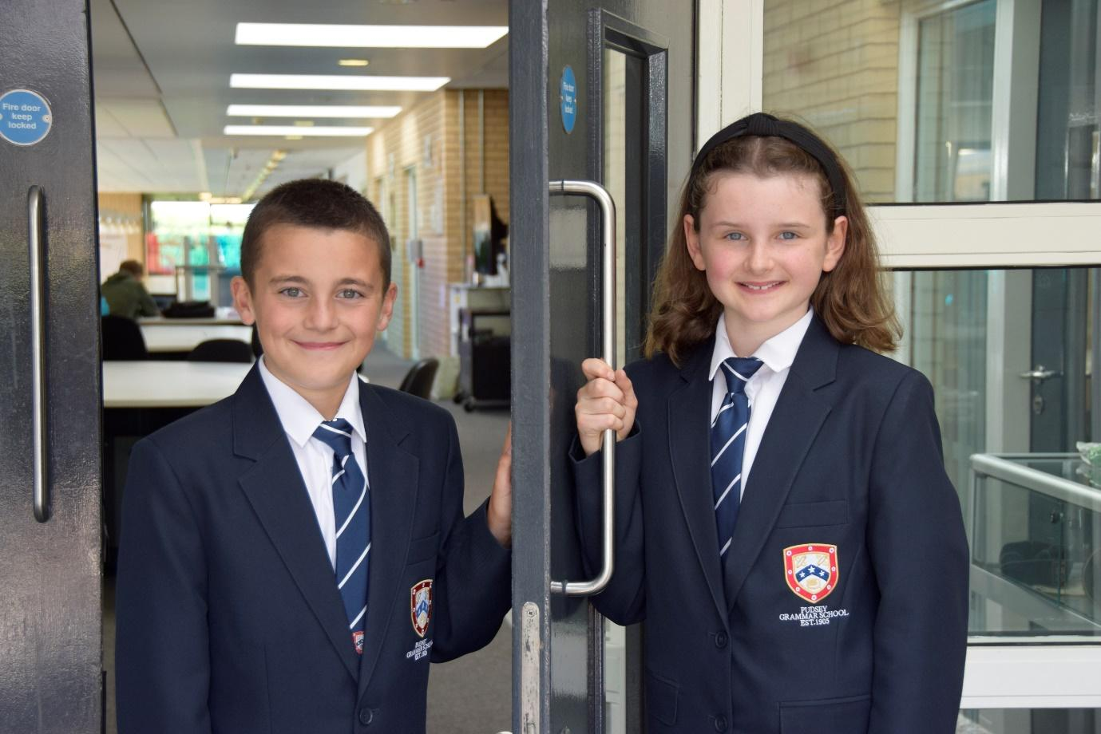

**TEACHER OF**

**ENGLISH**

**APPLICATION PACK**

**Behaviour Support Worker - Permanent**

**C3 £31,067 - £32,654 FTE**

**Actual Salary**

**£26,997 - £28,376**

**Term time only plus 5 days**

**Working pattern:**

**8.00am – 4.15pm Monday to Thursday**

**8.00 – 2.30pm Fridays**

**Start: As soon as possible**

**From September 2022**

**Contents**

Introduction from the Headteacher

General school details

Information on the post

Job description

Person specification

Enhanced disclosure

**Introduction from the Headteacher**

Thank you for the interest you have shown in the post of Behaviour Support Worker. This is an excellent opportunity to join our hard working and committed Student Support Team.

Pudsey Grammar School is a heavily oversubscribed mixed comprehensive secondary school located in the heart of the market town of Pudsey. Situated between Leeds and Bradford, the town has always valued its independence from its two larger neighbours. The school has a long and proud history stretching back to 1905. The school has 1400 students with a thriving and expanding Sixth Form of over 250 students, all taught in a state-of-the-art building. The innovative and unique style of the building creates a calm atmosphere very different to many secondary schools.

I was appointed in 2014 and since then we have received a letter from Amanda Spielman (HMCI Ofsted) which stated we ‘have transformed all aspects of the school.’ This assertion was further underlined in 2018 when the increase in our exam results resulted in the school being the most improved school in Leeds and one of the most improved in the country (we were delighted to follow these achievements up with our best ever GCSE exam results in 2019 which were above the national average). The pattern of improvement continued in 2020 with our Year 11 students achieving grades which were outstanding. The school had a highly successful Ofsted inspection in April 2019 and was judged as good in all areas, including our Sixth Form. The school underwent an ungraded inspection in April 2024 which saw, for the first time in the school’s history, a second successive Ofsted judgement of being a good school. This is testament to the consistently high quality of education which the school provides for all of our students and is one of the reasons why we remain one of the most popular schools across the city of Leeds with over 900 applications received for 215 Year 7 places for September 2024.

In 2022 the school was selected to be a national Behaviour Hub school. This was a Department for Education programme led by the Governments’ School Behaviour Advisor Tom Bennett which identifies school who have ‘an exemplary behaviour culture’. We were one of only 20 secondary schools out of 4000 who have achieved this prestigious accolade, and we worked with other schools across the north of England to improve their behaviour cultures.

We have a comprehensive House system which runs across all year groups with over 30 diverse competitions across the year for students and one each half term for staff too. House assemblies take place once every three weeks lead by our eight House Leaders. At the end of each academic year, the winning House is awarded our 80-year-old Victor Ludorum Cup

We are aiming to be a Centre of Excellence, and every indicator shows that we will achieve this goal. Continuing to recruit high calibre staff is a key priority of our strategy.

The following quotes are taken from the latest Ofsted report:

* *The school is welcoming, and pupils respect the differences in other people.*
* *Safeguarding is very well led, and pupils feel safe*
* *Pupils get on very well with each other*
* *Teachers have strong subject knowledge*
* *Pupils behave well in lessons and the vast majority focus on their work*
* *The school has developed an ambitious curriculum for pupils*
* *Staff have high expectations of all pupils. The vast majority of pupils rise to these expectations and work hard*
* *Pupils benefit from the curriculum and are well prepared for their next steps*
* *The House system plays a central role in the school and provides a sense of belonging. Pupils who earn House ties for their dedication to House competitions wear them with pride*
* *If bullying happens, pupils are confident that staff will deal with it quick*

The school has a long tradition in the town, being established as Pudsey Grammar School in 1905. Although the school is taught in a state-of-the-art building, our core values of respect, resilience, integrity, compassion and ambition are highly traditional and are based on the goal of ensuring that every student reaches their true potential.

Our school is not just about the student’s gaining knowledge and qualifications, although these are extremely important. We believe in teaching young people core values of decency, social skills and how to be a good citizen in an ever-changing world. We want their character to develop and grow, and for them to leave us with an inquiring and independent mind. We want our students to gain the best qualifications they are capable of whilst experiencing a range of opportunities which are second to none. As a result, the school is extremely popular with our community and is significantly over-subscribed every year.

Our Sixth Form, which is rated as good by Ofsted, has grown rapidly in recent years following significant investment and we now have over 250 post-16 students studying at Pudsey Grammar. We have a strong tradition of ensuring students access the best universities, including Oxford and Cambridge.

Our staff show exceptional dedication and commitment to our students. Relationships in the school are extremely strong and this underpins the ethos of the school. We pride ourselves in the care and support that we give our staff and, as a result, there is a real team spirit in the school where people enjoy being part of our school community. Teaching and learning is the key focus of the organisation and everything that we do is designed to ensure that the classroom experience for

the students are excellent. We are currently redesigning our curriculum to ensure that the education we offer is second to none.

We offer fantastic support and professional development to staff, which ensures that they are equipped with all the necessary skills to deliver excellent lessons to the students on a daily basis.

The school is a Foundation Trust school, and our partners include global companies such as M&S; HSBC bank, alongside leading local business and training provider, Appris. These high-quality links allow our school to offer excellent careers opportunities to students across the ability range. As a result, the school has 0% NEETs at Year 11.

We are currently part of The Leeds Teaching HUB, which is providing outstanding opportunities and CPD for all of our staff. Subject Leaders attend their Collaborative Learning Groups, which allows them to network and share best practice. This is further disseminated through the school via regular Department meetings and weekly Teaching & Learning briefings.

This clearly is an exciting time to join our school.

If you have a desire to be part of one of the most exciting and rewarding schools to work in, which will also provide you with excellent development opportunities, please complete the application form. Any further details can be obtained directly from the school's HR Team: [recruitment@pudseygrammar.co.uk](mailto:recruitment@pudseygrammar.co.uk)) or our website [www.pudseygrammar.co.uk](http://www.pudseygrangefield.co.uk)

**Mark McKelvie**

**Headteacher**

**Pudsey Grammar School**

**Job Title: Behaviour Support Worker**

**Hours and working pattern: 37 hpw, plus 5 training days 8.00am-4.15pm Monday to Thursday and 8.00am to 2.30pm Fridays)**

**Grade: C3, point 19 - 22**

**Salary: £31,067 - £32,654 FTE (£26,977- £28,376 Actual)**

**Start date: ASAP**

We are looking to appoint an exceptional individual to join our Pastoral Behaviour Team. The role involves working with students presenting a wide range of challenges to help them overcome these difficulties.  Applicants should have already demonstrated their commitment to working with young people, through either employment experience or a successful course of study.

The Behaviour Support Worker will have a calm approach, and the ability to use a range of techniques to help students manage their behaviour. We are looking for someone who is strong, resilient and able to operate in demanding situations that often require high levels of multi-tasking and prioritisation. The successful candidate will need to be highly efficient and have a consistently professional approach to all aspects of the role.

Candidates need to demonstrate

* A commitment to:
  + Working in line with statutory safeguarding guidance (e.g. Keeping Children Safe in Education, prevent and our safeguarding and child protection policies)
  + Working with the designated safeguarding lead (DSL) to promote the best interests of students, including sharing concerns where necessary
  + Promoting the safeguarding of all students in the school

**Why work at Pudsey Grammar School?**

* Be part of a rapidly improving school
* Work for an organisation which has staff wellbeing as its core
* Embrace the opportunity to play a key part in the continuing transformation of the school
* Be part of a dynamic and enthusiastic team of staff who are ensuring our students are successful in every way
* Work alongside hub-schools in the Yorkshire and Humber region and University College London, with access to high quality Teaching and Learning training, networking events, CPD
* Belong to a supportive organisation which prides itself on high standards for staff and students
* Work in an award-winning state of art building

**This school is committed to safeguarding and promoting the welfare of children and expects all staff and volunteers to share this commitment. Appointments will be subject to an enhanced DBS disclosure. If shortlisted, you will be required to disclose relevant information regarding criminal history and an on-line search will be conducted.  This includes only information publicly available on-line.**

**We promote diversity and want a workforce that reflects the population of Leeds.**

**Employment is conditional on confirmation of the right to work in the UK – either as a UK or Irish citizen, under the EU Settlement scheme or having secured any other relevant work visa. If you do not have the right to work in the UK and the role does not meet eligibility for sponsorship, please consider carefully whether you meet the eligibility to apply for this position.**

**Application Process**

Should you wish to apply for this position, please send the following to [recruitment@pudseygrammar.co.uk](mailto:recruitment@pudseygrammar.co.uk).

* A completed application form. Applications should be made electronically in Word or PDF format
* **Please be aware that we do not accept Curriculum Vitaes**
* In support of your application, you may include a covering letter. This should be in addition to the completed application form.

**Closing date for applications: 16.04.2025 at 8.00am**

**Successful candidates will be contacted directly with details of the interview.**

**Interview date: 30.04.2025**

**Job Description**

|  |  |
| --- | --- |
|  |  |
| Post Title: | Behaviour Support Worker |
|  |  |
| Post Purpose: | This is a key position in the school’s Student Support Team structure. The Behaviour Support Worker will provide support to students experiencing emotional difficulties, anger management, self-esteem, friendship/relationship difficulties. Applicants should have already demonstrated their commitment to working with young people, through either employment experience or a successful course of study. Furthermore, they should possess excellent interpersonal skills.  The Behaviour Support Teamwork alongside the Pastoral Team at Pudsey Grammar School, operating multi positions including isolation, inclusion, on call, intervention and SEMH support. The main roles of the need to access this support in school, ensuring their best chance of a positive experience whilst in our care. |
|  |  |
| Reporting to: | Assistant Headteacher |
|  |  |
| Working time: | 37 hours per week, term time plus 5 days  **8.00am-4.15pm Monday to Thursday**  **8.00am to 2.30pm Fridays**  There will be a requirement to attend staff training and departmental meetings as required which may fall outside of the set hours. |
|  |  |
| Salary/Grade: | C3 point 19 – 22, FTE, £31,067 – £32,654  Actual Salary, £26,997 - £28,376 |
|  |  |
| Main (Core) Duties: | |
|  |  |
|  | * Support students when they are removed from lessons, by taking students to a removal room. * To deal with logged incidents for behaviour in line with the School’s Behaviour Policy, when students behaviour doesn’t meet expectations. * To work with the Pastoral Team to ensure that school policies are followed, and sanctions are set as appropriate. * To provide support for students who are struggling with their social, emotional and mental well-being by providing purposeful timely intervention as directed. * Support in Isolation and Inclusion as needed to encourage a calm and purposeful atmosphere that is conductive to good behaviour, ensuring consistency and adhere to policy and behaviour requirements. * To support in the day to day running of the Isolation Unit, including leading ensuring students are effectively supervised and high standards of behaviour are achieved. * Assist in the smooth running of the on-call system/behaviour support rota to provide reinforcement to teachers who are experiencing difficulties in their classroom where students are displaying challenging behaviours. * Lead intervention groups/sessions as directed to students with emotional difficulties, anger management, self-esteem, friendship/relationship difficulties and assist them in developing strategies which will improve their behaviour and help them overcome barriers to learning. * Collaborate with the wider Pastoral Support team to provide additional capacity where required and supporting the work of Year Leaders and Directors of Studies * Provide capacity to the detention system. * Work with some of the hardest to reach students to advocate re-engagement with the school. Supporting with the work of the Attendance Team in terms of embedding strategies to encourage good attendance at school. * Develop relationships with students across the school, acting as a positive role model and enforcing the school’s behaviour policy with the purpose of improving whole school behaviour and reducing exclusions. * Maintain accurate records and analyse data to identify trends in student behaviour over time. * To undertake any other duties that are compatible with the post. * Deputise for Year Leader’s in the event of any absence |
|  |  |
| Manage Own Performance and Development | * Present a positive and professional personal image, contributing to a welcoming environment ensuring adherence to the standards and expectations outlined in the staff code of conduct. * Be aware of, comply with and assist with the development of systems and procedures e.g. health, safety and security, confidentiality and data protection, reporting all concerns to the appropriate person * Be aware of and support difference and ensure equal opportunities for all * Contribute to the overall ethos/work/aims of the school * Participate in training and other learning activities and performance development as required to enable continuous growth and development * Attend all appropriate meetings as required by the Line Manager * The duties outlined are not meant as an exhaustive list and will also comprise any other duties within the spirit of the post commensurate with the job evaluation outcome for this post. |
|  |  |
| Relationships | * The post-holder will be required to work flexibly to deliver an efficient Service. This may include some work to be undertaken outside of normal working hours. * There will be regular contact with pupils, colleagues, other members of staff, line managers and internal and external customers * Support extra-curricular and other school events as part of the schools’ community link. |
|  |  |
| Safeguarding | * To work in line with statutory safeguarding guidance (e.g. Keeping Children Safe in Education, prevent and our safeguarding and child protection policies) * To work with the designated safeguarding lead (DSL) to promote the best interests of students, including sharing concerns where necessary * To promote the safeguarding of all students in the school. |
|  |  |
| Physical conditions | * The post is based at Pudsey Grammar School * The school is accessible by stairs and lift and is available by disabled persons to the ground floor by a portable ramp on request * This post is subject to an enhanced Disclose and Barring Service check * The school operates a non-smoking policy |
|  |  |
| Prospects | Whilst there is no automatic progression to any more senior posts, opportunities do exist for advancement and promotion, dependent upon normal staff movements and on the capabilities of the individual post holder. |
|  |  |
| Training | The school encourages training both “in-house” and external to meet the needs of the individual and of the Service. |
|  |  |
| Any Special Conditions of Service: No smoking policy | |
|  |  |
| This job description is to assist staff joining Pudsey Grammar School to understand and appreciate the work content of their post and the role they are to play in the organisation.  Whilst every endeavour has been made to outline the main duties and responsibilities of the post, a document such as this does not permit every item to be specified in detail. This job description is not a definitive list of responsibilities but identifies the key components of the role. The post holder will, therefore, be required to undertake other reasonable duties commensurate with the purpose and salary level of this post.  Employees should not refuse to undertake work, which is not specified on this form, but they should record any additional duties they are required to perform, and these will be taken into account when the post is reviewed.  All new appointments of support staff are made subject to the satisfactory completion of a six-month probationary period. | |
|  | |
| **Statement:**  **This school is committed to safeguarding and promoting the welfare of children and expects all staff and volunteers to share this commitment. Appointments will be subject to an enhanced DBS disclosure. If shortlisted, you will be required to disclose relevant information regarding criminal history and an on-line search will be conducted.  This includes only information publicly available on-line. The employee may be subject to rechecking as required from time to time.**  **All appointments are subject to satisfactory references.**  Pudsey Grammar School is an equal opportunities employer and requires its employees to comply with all current equality policies both in terms of equal opportunity for employment and access to the school’s services.  We promote diversity and want a workforce which reflects the population of Leeds.  Dated: March 2025 | |

Person Specification Behaviour Support Worker

|  |  |  |
| --- | --- | --- |
| SKILLS | Ess | Des |
| Ability to juggle multiple demands and priorities | * |  |
| Very good numeracy/literacy skills | * |  |
| Ability to relate well to children and adults, building positive relationships | * |  |
| Ability to work constructively as part of a team | * |  |
| Flexible and able to use own initiative | * |  |
| Negotiating skills |  | * |
| Good written and spoken communication skills | * |  |
| Good at forward planning |  | * |
| Good organisational skills |  | * |
| Strong behaviour management skills | * |  |
| Ability to manage challenging situations and de-escalate issues calmly | * |  |
| Ability to use IT systems competently to aid analysis (e.g. Arbor, Classcharts) |  | * |

|  |  |  |
| --- | --- | --- |
| KNOWLEDGE/QUALIFICATIONS | Ess | Des |
| GCSE English and Maths Grade C or equivalent | * |  |
| At least Level 3 NVQ equivalent or higher | * |  |

|  |  |  |
| --- | --- | --- |
| EXPERIENCE | Ess | Des |
| Experience working with children or young people in an educational setting | * |  |
| Experience of working with adolescence with difficult or challenging behaviour | * |  |

|  |  |  |
| --- | --- | --- |
| BEHAVIOURAL AND OTHER RELATED CHARACTERISTICS | Ess | Des |
| Willing to abide by the Council’s Equal Opportunities Policy in the duties of the post, and as an employee of the Council. | * |  |
| Willing to carry out all duties having regard to an employee’s responsibility under the Council’s Health and Safety Policies | * |  |
| Demonstrate a calm demeanour | * |  |
| Ability to stay calm under pressure | * |  |
| Demonstrate resilience at all times | * |  |
| To display a responsible and co-operative attitude to working towards the achievement of the school’s aims and objectives | * |  |
| An ability to respect sensitive and confidential work. | * |  |
| Commitment to own personal development and learning. | * |  |
| Able to respond flexibly to meet daily demands of the role, showing independence and being proactive | * |  |
| Able to work collaboratively with the wider Student Support Team | * |  |
| A willingness to become involved in the wider aspects of the school |  | * |

**Enhanced Disclosure**

Thank you for your interest in this post at Pudsey Grammar School. The post you are applying for involves working with young people. It is therefore exempt from the Rehabilitation of Offenders Act and any offer of employment will be subject to an Enhanced Disclosure.

As this post is exempt from the Rehabilitation of Offenders Act, you must declare any convictions, including pending convictions, cautions, reprimands and warnings which would otherwise be regarded as “spent” under this Act. Further details will be sought prior to appointment.

An Enhanced Disclosure is carried out by the Criminal Records Bureau and will check criminal records for information on any convictions, cautions, reprimands and warnings held on the Police National Computer and on local Police records.

All information on criminal records provided both by you and within the Enhanced Disclosure will be used, stored and disposed of in confidence and in line with the Criminal Records Bureau Code of Practice of Disclosure Information.

If your application is successful, you will receive further information on how to complete the Enhanced Disclosure.

***We are committed to safeguarding and promoting the welfare of our pupils and expect all staff and volunteers to share this commitment.***

**School Location and Travel Information**

### Pudsey Grammar School

Mount Pleasant Road

Pudsey

Leeds

LS28 7ND

### Tel: 0113 2558277

### [www.pudseygrammar.co.uk](http://www.pudseygrangefield.co.uk)

Instagram/Twitter/Facebook - @PudseyGS

