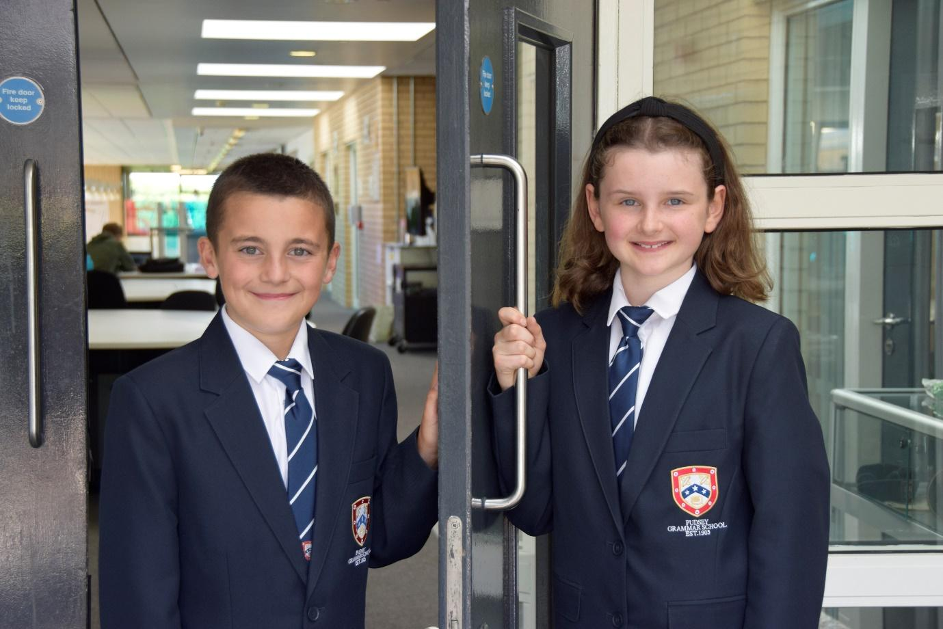

**TEACHER OF**

**ENGLISH**

**APPLICATION PACK**

**Teacher of Music**

**with Drama**

**Part-time hours will be considered and welcomed for the right candidate**

**The school operates a flexible early finish on Fridays**

**MPS/UPS**

**£31,650 - £49,084**

**From September 2025**

**Contents**

Introduction from the Headteacher

General school details

Information on the post

Job description

Person specification

Enhanced disclosure

**Introduction from the Headteacher**

Thank you for the interest you have shown in the post of Teacher of Music with Drama. This is an excellent opportunity to join our dynamic Performing Arts Team.

Pudsey Grammar School is a heavily oversubscribed mixed comprehensive secondary school located in the heart of the market town of Pudsey. Situated between Leeds and Bradford, the town has always valued its independence from its two larger neighbours. The school has a long and proud history stretching back to 1905. The school has 1350 students with a thriving and expanding Sixth Form of over 250 students, all taught in a state of the art building. The innovative and unique style of the building creates a calm atmosphere very different to many secondary schools.

I was appointed in 2014 and since then we have received a letter from Amanda Spielman (HMCI Ofsted) which stated we ‘have transformed all aspects of the school.’ This assertion was further underlined in 2018 when the increase in our exam results resulted in the school being the most improved school in Leeds and one of the most improved in the country (we were delighted to follow these achievements up with our best ever GCSE exam results in 2019 which were above the national average). The pattern of improvement continued in 2020 with our Year 11 students achieving grades which were outstanding. The school had a highly successful Ofsted inspection in April 2019 and was judged as good in all areas, including our Sixth Form. The school underwent an ungraded inspection in April 2024 which saw, for the first time in the school’s history, a second successive Ofsted judgement of being a good school. This is testament to the consistently high quality of education which the school provides for all of our students and is one of the reasons why we remain one of the most popular schools across the city of Leeds with over 900 applications received for 215 Year 7 places for September 2024.

In 2022, the school was selected to be a national Behaviour Hub school. This was a Department for Education programme led by the Governments’ School Behaviour Advisor, Tom Bennett, which identifies schools who have ‘an exemplary behaviour culture’. We were one of only 20 secondary schools out of 4000 who have achieved this prestigious accolade, and we worked with other schools across the north of England to improve their behaviour cultures.

We have a comprehensive House system which runs across all year groups with over 30 diverse competitions across the year for students and one each half term for staff too. House assemblies take place once every three weeks lead by our eight House Leaders. At the end of each academic year, the winning House is awarded our 80-year-old Victor Ludorum Cup.

We are aiming to be a centre of excellence and every indicator we have, we are on track to achieve this goal. Continuing to recruit high calibre staff is a key priority of our strategy.

The following quotes are taken from the latest Ofsted report:

* *The school is welcoming, and pupils respect the differences in other people.*
* *Safeguarding is very well led, and pupils feel safe*
* *Pupils get on very well with each other*
* *Teachers have strong subject knowledge*
* *Pupils behave well in lessons and the vast majority focus on their work*
* *The school has developed an ambitious curriculum for pupils*
* *Staff have high expectations of all pupils. The vast majority of pupils rise to these expectations and work hard*
* *Pupils benefit from the curriculum and are well prepared for their next steps*
* *The House system plays a central role in the school and provides a sense of belonging. Pupils who earn House ties for their dedication to House competitions wear them with pride*
* *If bullying happens, pupils are confident that staff will deal with it quickly*

The school has a long tradition in the town, being established as Pudsey Grammar School in 1905. Although the school is taught in a state of the art building, our core values of respect, resilience, integrity, compassion and ambition are highly traditional and are based on the goal of ensuring that every student reaches their true potential.

Our school is not just about the students gaining knowledge and qualifications, although these are extremely important. We believe in teaching young people core values of decency, social skills and how to be a good citizen in an ever changing world. We want their character to develop and grow, and for them to leave us with an inquiring and independent mind. We want our students to gain the best qualifications they are capable of whilst experiencing a range of opportunities which are second to none. As a result, the school is extremely popular with our community and is significantly over-subscribed every year.

Our Sixth Form, which is rated as good by Ofsted, has grown rapidly in recent years following significant investment and we now have over 250 Post-16 students studying at Pudsey Grammar. We have a strong tradition of ensuring students access the best universities, including Oxford and Cambridge.

Our staff show exceptional dedication and commitment to our students. Relationships in the school are extremely strong and this underpins the ethos of the school. We pride ourselves in the care and support that we give our staff and, as a result, there is a real team spirit in the school where people enjoy being part of our school community. Teaching and learning is the key focus of the organisation and everything that we do is designed to ensure that the classroom experience for

the students is excellent. We are currently redesigning our curriculum to ensure that the education we offer is second to none.

We offer fantastic support and professional development to staff, which ensures that they are equipped with all the necessary skills to deliver excellent lessons to the students on a daily basis.

The school is a Foundation Trust school and our partners include global companies such as M&S and HSBC bank, alongside leading local business and training provider, Appris. These high quality links allow our school to offer excellent careers

opportunities to students across the ability range. As a result, the school has 0% NEETs at Year 11.

We are currently part of The Leeds Teaching School Hub, which is providing outstanding opportunities and CPD for all of our staff. Subject Leaders attend their Collaborative Learning Groups, which allows them to network and share best practice. This is further disseminated through the school via regular Department meetings and weekly Teaching & Learning briefings.

This clearly is an exciting time to join our school.

If you have a desire to be part of one of the most exciting and rewarding schools to work in, which will also provide you with excellent development opportunities, please complete the application form. Any further details can be obtained directly from the school’s HR Team: [recruitment@pudseygrammar.co.uk](mailto:recruitment@pudseygrammar.co.uk)) or our website [www.pudseygrammar.co.uk](http://www.pudseygrangefield.co.uk)

**Mark McKelvie**

**Headteacher**

**Pudsey Grammar School**

**Departmental Information**

**Music**

The Music Department is led by a Music specialist and also consists of 4 peripatetic staff who visit the school throughout the week to support instrumental tuition. The department has two music classrooms, both complete with a class set of keyboards and practice rooms which are fully equipped with a range of instrumental resources, iMacs and recording equipment. In addition, access is available to a Mac suite for use with KS4 and Chromebook use for lessons across all year groups.

Music is taught to all students in Year 7, 8 & 9.  In Year 10 and 11, the BTEC Tech Award in Music Practice is offered as an option subject, therefore providing students of all interests and abilities access to learning at KS4. Students who choose to study music at KS4 are provided with school funded instrumental tuition in order to support their performance skills development. All students are offered the opportunity to receive instrumental tuition within school across a range of instruments including piano, vocals, drums, violin and guitar, which has proven very popular.

**Drama**

Our well-established and successful Drama Department is led by a subject specialist in Performing Arts. The department works closely alongside the Music and Media Departments and offers our students excellent facilities that include a fully equipped Drama Studio and school auditorium where our major productions are held.

Drama is taught to all students in Year 7, 8 and 9. The subject is offered to Key Stage 4 students in Years 10, 11 and KS5 for Post 16 students. We also provide opportunities for Post 16 students to direct their own musical performance each year, which is very popular with students.

**Extra-curricular**

Extra-curricular activities are extremely popular within the Drama and Music departments and are well received within the wider community. Students have the opportunity to take part in the school production, vocal group, school band, spotlight (6th form lead production/club), theatre visits and residential trips that include theatre workshops and watching live West End performances. 'Extra-curricular is run in collaboration with all of the Performing Arts team and candidates will therefore be expected to contribute to this aspect of both departments'.

Our school productions are always incredibly popular. This year was an outstanding performance of Annie showcased across 3 nights with students performing from Years 7 to 13.

**Department development**

We are keen to develop music technology, sound and lighting provision both within curriculum lessons and as part of extra-curricular activities within the department, which would provide an excellent opportunity for the right candidate to make an impact in this area.

Our school productions are always incredibly popular. This year was an outstanding performance of Matilda showcased across 3 nights with students performing from Years 7 to 13.

**Details of advert**

**Job Role: Permanent - Teacher of Music with Drama**

**Grade: MPS/UPS, £31,650 - £49,084**

**Start date: September 2025**

**Part-time hours will be considered and welcomed for the right candidate**

***The school operates a flexible early finish on Fridays***

We are looking for an exceptional and highly motivated teacher to join our talented and forward-thinking performing arts department (teaching across both music and drama subject areas), where you will be supported and developed to ensure that you deliver inspirational and innovative teaching on a daily basis. The team works collaboratively to share good practice and to improve teaching and learning across the department and benefits from excellent facilities including a fully equipped drama studio, school auditorium and recording studio.

The successful candidate would be joining a very enthusiastic, motivated and dedicated team where student progress is the focal point.

Pudsey Grammar School has an excellent reputation in the local community, being the second most oversubscribed school in Leeds.

We are looking for an outstanding candidate who would be keen to:

* Teach across Key Stage 3, 4 and 5
* Work within music and drama to develop an exciting range of extra-curricular activities and promote our hugely successful school productions
* Contribute to and continue to develop our well-established and successful schemes of work and curriculum across all key stages in music and drama
* Work cohesively within a department that is committed to developing new ways of teaching and learning that focus on student needs
* Promote and safeguard the welfare of children and young people in accordance with our Safeguarding and Child Protection policies.

**Why work at Pudsey Grammar School?**

* Be part of a rapidly improving school which stands as the second most oversubscribed school in the city
* Work for an organisation which has staff wellbeing as its core
* Embrace the opportunity to play a key part in the continuing transformation of the school
* Be part of a dynamic and enthusiastic team of staff who are ensuring our students are successful in every way
* Work alongside hub-schools in the Yorkshire and Humber region and University College London, with access to high quality Teaching and Learning training, networking events, CPD and national teacher meetings held annually in London.
* Belong to a supportive organisation which prides itself on high standards for staff and students
* Work in an award-winning state of art building

**This school is committed to safeguarding and promoting the welfare of children and expects all staff and volunteers to share this commitment. Appointments will be subject to an enhanced DBS disclosure. If shortlisted, you will be required to disclose relevant information regarding criminal history and an on-line search will be conducted.  This includes only information publicly available on-line.**

**We promote diversity and want a workforce that reflects the population of Leeds.**

**Employment is conditional on confirmation of the right to work in the UK – either as a UK or Irish citizen, under the EU Settlement scheme or having secured any other relevant work visa. If you do not have the right to work in the UK and the role does not meet eligibility for sponsorship, please consider carefully whether you meet the eligibility to apply for this position.**

**Application Process**

Should you wish to apply for this position, please send the following to [recruitment@pudseygrammar.co.uk](mailto:recruitment@pudseygrammar.co.uk).

* A completed application form. Applications should be made electronically in Word or PDF format
* **Please be aware that we do not accept Curriculum Vitaes**
* In support of your application, you may include a covering letter. This should be in addition to the completed application form.

**Closing date for application 4th April 2025 at 8.00am**

**Successful candidates will be contacted directly with details of the interview.**

**Interview date: 23rd April 2025**

**Job Description**

|  |  |
| --- | --- |
|  |  |
| Post Title: | Teacher of Music with Drama |
|  |  |
| Post Purpose: | * To facilitate and encourage learning which enables students to make progress and achieve high standards; to share and support the corporate responsibility for the well-being, education and positive behaviour of all students. * To contribute to the positive ethos of the school. * To be responsible for the health and safety of themselves and those around them. * To implement the school’s policies and procedures. * To work as part of curriculum and pastoral teams to effect the school’s mission statement, ensure a strong commitment to Every Child Matters, as well as provide effective high quality teaching and learning. |
|  |  |
| Reporting to: | Subject Leader of Performing Arts |
|  |  |
| Working time: | Full time (Permanent) – From September 2025  **Part-time hours will be considered and welcomed for the right candidate**  School operates an early finish on a Friday |
|  |  |
| Salary/Grade: | MPS/UPS £31,650 - £49,084 |
|  |  |
| Main (Core) Duties: | |
|  |  |
| Teaching & Leading Student Learning | * Ensure effective learning of whole classes, groups and individuals so that teaching and learning objectives are met, momentum and challenge are maintained, and students’ targets are achieved or exceeded. * Utilise teaching methods which engage students, including stimulating intellectual curiosity, effective questioning and discussion, clear presentation and good use of resources. * Set high expectations for students' behaviour, establishing and maintaining a good standard of discipline through well-focused teaching and learning experiences and through positive and productive relationships. Lead this process in accordance with school policies and procedures. * Make use of a variety of techniques to support knowledge retrieval * Use a variety of Assessment for learning strategies to ensure teaching is responsive to student need. |
|  |  |
| Planning and Setting Expectations/Student Achievement | * Identify clear learning objectives, content, lesson structures and sequences appropriate to the subject matter and the students being taught. * Set appropriate and demanding expectations for students’ learning and motivation. Set clear targets for students' learning, building on prior attainment. * Plan appropriate learning programmes for students who have special educational needs, and know where to get help in order to give positive and targeted support. Implement and keep records on Individual Education Plans (IEPs). |
|  |  |
| Assessment and Evaluation | * Assess how well learning objectives have been achieved and use this assessment for future teaching. * Mark and monitor students’ class and homework providing constructive oral and written feedback, in line with the school’s Marking Policy. * Where applicable, understand the demands expected of students in relation to the National Curriculum, KS4 and post-16 courses. |
|  |  |
| Relationship with Parents/Carers and the Wider community | * Prepare and present informative reports to parents. * Provide opportunities to develop students' understanding by relating their learning to real and work-related examples, recognising that learning also takes place outside the school context. * Liaise with agencies responsible for students' welfare. |
|  |  |
| Working and Colleague Relationships | * To establish effective working relationships with professional colleagues including, where applicable, support staff. |
|  |  |
| Manage Own Performance and Development | * Take responsibility for their own professional development and to keep up to date with research and developments in pedagogy and in the subjects they teach. * Share corporate responsibility the implementation of school policies and practices. * Provide a role model to all students they encounter, in their presentation and their personal conduct. * Evaluate their own teaching critically and use this to improve their effectiveness. |
|  |  |
| Safeguarding | * To work in line with statutory safeguarding guidance (e.g. Keeping Children Safe in Education, prevent and our safeguarding and child protection policies) * To work with the designated safeguarding lead (DSL) to promote the best interests of students, including sharing concerns where necessary. * To promote the safeguarding of all students in the school. |
|  |  |
| Physical conditions | * The post is based at Pudsey Grammar School. * The school is accessible by stairs and lift and is available by disabled persons to the ground floor by a portable ramp on request. * This post is subject to an enhanced Disclose and Barring Service check. * The school operates a non-smoking policy. |
|  |  |
| Prospects | * Whilst there is no automatic progression to any more senior posts, opportunities do exist for advancement and promotion, dependent upon normal staff movements and on the capabilities of the individual post holder. |
|  |  |
| Training | * The school encourages training both “in-house” and external to meet the needs of the individual and of the Service.. |
|  |  |
| |  | | --- | | This job description is to assist staff joining Pudsey Grammar School to understand and appreciate the work content of their post and the role they are to play in the organisation.  Whilst every endeavour has been made to outline the main duties and responsibilities of the post, a document such as this does not permit every item to be specified in detail. This job description is not a definitive list of responsibilities but identifies the key components of the role. The post holder will, therefore, be required to undertake other reasonable duties commensurate with the purpose and salary level of this post.  Employees should not refuse to undertake work, which is not specified on this form, but they should record any additional duties they are required to perform, and these will be taken into account when the post is reviewed.  All new appointments of support staff are made subject to the satisfactory completion of a six-month probationary period. | | **Statement:**  **This school is committed to safeguarding and promoting the welfare of children and expects all staff and volunteers to share this commitment. Appointments will be subject to an enhanced DBS disclosure. If shortlisted, you will be required to disclose relevant information regarding criminal history and an on-line search will be conducted.  This includes only information publicly available on-line. The employee may be subject to rechecking as required from time to time.**  **All appointments are subject to satisfactory references.**  Pudsey Grammar School is an equal opportunities employer and requires its employees to comply with all current equality policies both in terms of equal opportunity for employment and access to the school’s services.  We promote diversity and want a workforce which reflects the population of Leeds.  Dated: March 2025 | | |
|  | |

The Job Description should be read alongside the range of professional duties of Teachers as set out in Part X11 of the Teachers’ Pay and Conditions Document, sections 48 to 50. The postholder will be expected to undertake duties in line with the new Professional Standards for Teachers (2008) and uphold the professional code of the General Teaching Council for England.

Person Specification

|  |  |  |  |
| --- | --- | --- | --- |
| **ATTRIBUTES** | **REQUIREMENTS** | **ESSENTIAL** | **DESIREABLE** |
| Qualifications, Training & Knowledge | * Degree in specialist/relevant subject area; * Qualified Teacher Status; * Good knowledge of current educational developments, especially in specialist/relevant subject area. * Good knowledge of the requirements of the Leeds Locally Agreed Syllabus; * Knowledge of strategies for raising attainment; | **\***  **\***  **\***  **\***  **\*** |  |
| Experience | * Teaching experience of secondary school (in specialist/relevant area). | * |  |
| Skills | * A good team member; * Flexible and able to use own initiative; * Ability to inspire and motivate students; * Good ICT skills; including editing software * Good written and spoken communication skills. | *  *  *  *  * |  |
| Personal Qualities | * Evidence of effective organisational and communication skills; * Evidence of being a successful teacher; * Capable of inspiring students; * Able to form good working relationships with colleagues; * A willingness to become fully involved in the wider life of Pudsey Grammar School. | *  *  *  *  * |  |

### **School Location and Travel Information**

Pudsey Grammar School

Mount Pleasant Road

Pudsey

Leeds

LS28 7ND

Tel: 0113 2558277

Twitter - @PudseyGS

[www.pudseygrammar.co.uk](http://www.pudseygrammar.co.uk)

