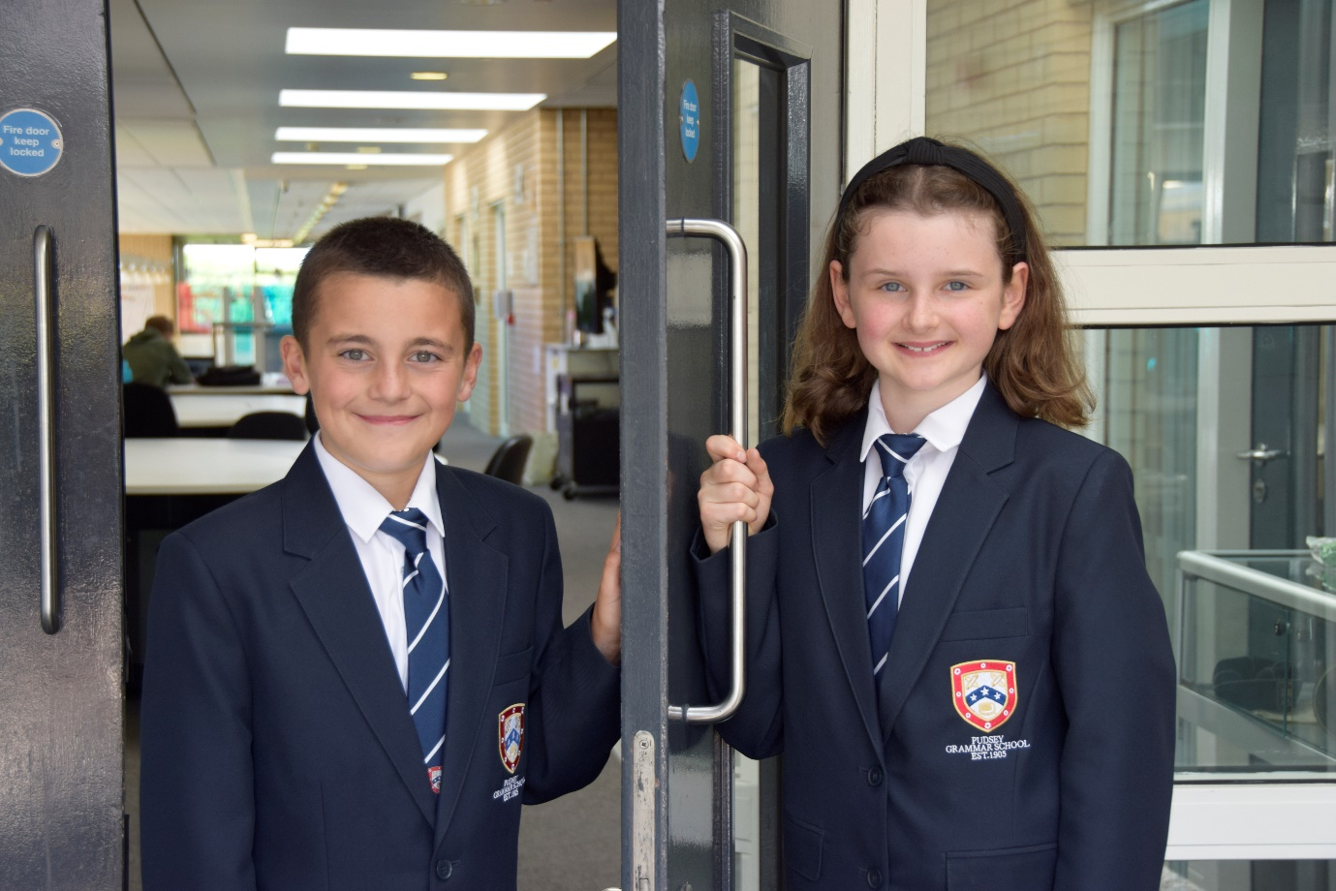

**TEACHER OF**

**ENGLISH**

**APPLICATION PACK**

**Associate Teacher - Permanent**

**C1 (£26,421 - £28,770)**

**Actual salary (£22,724 - £24,771)**

**37 hours per week term time only plus 5 days**

**Working pattern to be confirmed (the school operates an early finish on Fridays from September 2024)**

**Start: As soon as possible**

Contents

1. Introduction from the Headteacher
2. Information on the post
3. Job description
4. Person specification
5. Enhanced disclosure
6. School Location and Travel Information

**Introduction from the Headteacher**

Thank you for the interest you have shown in the post of Associate Teacher at our school. This is an excellent opportunity to join our dynamic Student Support Team.

Pudsey Grammar School is a heavily oversubscribed mixed comprehensive secondary school located in the heart of the market town of Pudsey. Situated between Leeds and Bradford the town has always valued its independence from its two larger neighbours. The school has a long and proud history stretching back to 1905. The school has 1350 students with a thriving and expanding Sixth Form of over 250 students all taught in a state-of-the-art building. The innovative and unique style of the building creates a calm atmosphere very different to many secondary schools.

I was appointed in 2014 and since then we have received a letter from Amanda Spielman (HMCI Ofsted) which stated we ‘have transformed all aspects of the school.’ This assertion was further underlined in 2018 when the increase in our exam results resulted in the school being the most improved school in Leeds and one of the most improved in the country (we were delighted to follow these achievements up with our best ever GCSE exam results in 2019 which were above the national average). The pattern of improvement continued in 2020 with our Year 11 students achieving grades, which were outstanding. The school had a highly successful Ofsted inspection in April 2019 and was judged as good in all areas including our sixth form. The school underwent an ungraded inspection in April 2024 which saw, for the first time in the school’s history, a second successive Ofsted judgement of being a good school. This is testament to the consistently high quality of education which the school provides for all of our students and is one of the reasons why we remain one of the most popular schools across the city of Leeds with over 900 applications received for 215 Year 7 places for September 2024.

In 2022, the school was selected to be a national Behaviour Hub school. This is a Department for Education programme led by the Governments’ School Behaviour Advisor, Tom Bennett, which identifies schools who have ‘an exemplary behaviour culture’. We are one of only 20 secondary schools out of 4000 who have achieved this prestigious accolade, and we are working with other schools across the north of England to improve their behaviour cultures.

In 2023, the school was awarded £4million by the Department for Education to build a new Sixth Form to support the growth in student numbers across Leeds. This exciting new development is scheduled to open in early 2025.

We have a comprehensive House system which runs across all year groups with over 30 diverse competitions across the year for students and one each half term for staff too. House assemblies take place once every three weeks lead by our eight House Leaders. At the end of each academic year, the winning House is awarded our 80-year-old Victor Ludorum Cup.

We are aiming to be a centre of excellence and every indicator we have; we are on track to achieve this goal. Continuing to recruit high calibre staff is a key priority of our strategy.

The following quotes are taken from the latest Ofsted report:

* *The school is welcoming and pupils respect the differences in other people.*
* *Safeguarding is very well led, and pupils feel safe*
* *Pupils get on very well with each other*
* *Teachers have strong subject knowledge*
* *Pupils behave well in lessons and the vast majority focus on their work*
* *The school has developed an ambitious curriculum for pupils*
* *Staff have high expectations of all pupils. The vast majority of pupils rise to these expectations and work hard*
* *Pupils benefit from the curriculum and are well prepared for their next steps*
* *The House system plays a central role in the school and provides a sense of belonging. Pupils who earn House ties for their dedication to House competitions wear them with pride*
* *If bullying happens, pupils are confident that staff will deal with it quickly*

The school has a long tradition in the town, being established as Pudsey Grammar School in 1905. Although the school is taught in a state-of-the-art building, our core values of respect, resilience, integrity, compassion and ambition are highly traditional and are based on the goal of ensuring that every student reaches their true potential.

Our school is not just about the student’s gaining knowledge and qualifications, although these are extremely important. We believe in teaching young people core values of decency, social skills and how to be a good citizen in an ever changing world. We want their character to develop and grow and for them to leave us with an inquiring and independent mind. We want our students to gain the best qualifications they are capable of whilst experiencing a range of opportunities which are second to none. As a result, the school is extremely popular with our community and is significantly over-subscribed every year.

Our Sixth Form, which is rated as good by Ofsted, has grown in recent years and we now have over 250 Post-16 students studying at Pudsey Grammar. We have a strong tradition of ensuring students access the best universities including Oxford and Cambridge.

Our staff show exceptional dedication and commitment to our students. Relationships in the school are extremely strong and this underpins the ethos of the school. We pride ourselves in the care and support that we give our staff and as a result there is a real team spirit in the school where people enjoy being part of

our school community. Teaching and learning is the key focus of the organisation and everything that we do is designed to ensure that the classroom experience for the students is excellent. We are currently redesigning our curriculum to ensure that the education we offer is second to none.

We offer fantastic support and professional development to staff which ensures that everyone is equipped with all the necessary skills to be an excellent practitioner and deliver a first class education to all students.

The school is a foundation Trust school and our partners include global companies such as Asda, HSBC bank alongside leading local business and training provider, Appris. These high quality links allow our school to offer excellent careers

opportunities to students across the ability range. As a result, the school has 0% NEETs at Year 11.

We are currently part of the Red Kite Teaching Alliance which is providing outstanding opportunities and CPD for all of our staff. Subject Leaders attend their Collaborative Learning Groups, which allows them to network and share best practice. This is further disseminated through the school via regular department meetings and weekly Teaching & Learning briefings.

This clearly is an exciting time to join our school.

If you have a desire to work in one of the most exciting and rewarding schools, which will also provide you with excellent development opportunities, please complete the application form. Any further details can be obtained directly from the school’s HR Team: [recruitment@pudseygrammar.co.uk](mailto:recruitment@pudseygrammar.co.uk) or visit our website [www.pudseygrammar.co.uk](http://www.pudseygrangefield.co.uk)

**Mark McKelvie**

**Headteacher**

**Pudsey Grammar School**

**Details of advert**

**Job Title: Associate Teacher - Permanent**

**Hours and working pattern: 37hpw, actual working pattern to be confirmed (the school operates a flexible early finish on Fridays from September 2024)**

**Grade: C1, 12 - 17**

**Salary: £26,421 - £28,770 FTE (£22,724 - £24,771 Actual)**

**Start date: ASAP**

We are looking to recruit an exceptional candidate to join our highly valued team of associate teacher’s. The Associate Teacher role plays a key part in the school’s curriculum delivery.

The role would particularly suit someone who is thinking about a career in teaching or working towards this. In 2022, the school was selected as a Lead school as part of the DFE’s Behaviour Hubs programme and the successful candidate will have the opportunity to develop their skill, practice and knowledge working alongside ambitious and successful colleagues who lead on behaviour management.

Working under the guidance of teaching staff/middle leaders within an agreed system of supervision, to implement work programmes with individual groups, in or out of the classroom. There will be some involvement with the whole planning cycle to enable development of specialist knowledge in particular areas.

The successful candidate will be required to supervise the work that has been set in the lesson plan provided, using necessary resources that we also provide. Covering whole classes during the short-term absence of teachers.

**Applicants will need to demonstrate:**

* Excellent attention to detail, effective analytical skills and strong inter-personal and communication skills, together with the ability to work as part of a successful team.
* Applicants should have appropriate qualifications and/or relevant experience in working with young people.
* A commitment to:
  + Working in line with statutory safeguarding guidance (e.g. Keeping Children Safe in Education, prevent and our safeguarding and child protection policies)
  + Will have responsibility for receiving and acting upon any reported concerns and ensuring that the Child Protection Policy is implemented and promote best safeguarding practice across the school as part of the Student Support Team.
  + Promoting the safeguarding of all students in the school

**Why work at Pudsey Grammar School?**

* Be a part of our rapidly improving school
* An organisation which has staff wellbeing as its core
* The opportunity to play a key part in the continuing transformation of the school
* The successful candidate will join a dynamic and enthusiastic team of staff who are ensuring our students are successful in every way
* Have the opportunity to work alongside hub-schools in the Yorkshire and Humber region and University College London, with access to high quality Teaching and Learning training, networking events, CPD and national teacher meetings held annually in London.
* Be part of a supportive organisation which prides itself on high standards for staff and students
* Work in an award-winning state of art building

**This school is committed to safeguarding and promoting the welfare of children and expects all staff and volunteers to share this commitment. Appointments will be subject to an enhanced DBS disclosure. If shortlisted, you will be required to disclose relevant information regarding criminal history and an on-line search will be conducted.  This includes only information publicly available on-line.**

**We promote diversity and want a workforce that reflects the population of Leeds.**

**Employment is conditional on confirmation of the right to work in the UK – either as a UK or Irish citizen, under the EU Settlement scheme or having secured any other relevant work visa. If you do not have the right to work in the UK and the role does not meet eligibility for sponsorship, please consider carefully whether you meet the eligibility to apply for this position.**

**Application Process**

Should you wish to apply for this position, please send the following:

* A completed application form.
* Applications should be made electronically in Word or PDF format to [recruitment@pudseygrammar.co.uk](mailto:recruitment@pudseygrammar.co.uk).
* **Please be aware that we do not accept Curriculum Vitaes**.
* In support of your application, you may include a covering letter. This should be in addition to the completed application form.

**Closing date for applications: Tuesday 12th November 2024 at 12 noon.**

**Successful candidates will be contacted directly with details of the interview.**

**Interview date: Wednesday 20th November**

**Job Description**

|  |  |
| --- | --- |
|  |  |
| Post Title: | Associate Teacher |
|  |  |
| Post Purpose: | The successful candidate will work under the guidance of teaching/senior staff and within an agreed system of supervision, to implement agreed work programmes with individual groups, in or out of the classroom. This could include those requiring detailed and specialist knowledge in particular areas and will involve assisting the teacher in the whole planning cycle and the management/preparation of resources. Staff may also supervise whole classes occasionally during the short-term absence of teachers, limited to a maximum of 3 consecutive days for any one absence. The primary focus will be to maintain good order and to keep pupils on task. Associate Teacher’s will need to respond to questions and generally assist pupils to undertake set activities. Marking and assessment activities are limited to those where answers are predetermined, and no element of professional judgement is required. |
|  |  |
| Reporting to: | Teaching & Learning Practioner |
|  |  |
| Working time: | 37 hours per week, term time plus 5 days  Working pattern to be confirmed (the school operates an early finish on Fridays from September 2024) |
|  |  |
| Salary/Grade: | C1 (£26,421 - £28,770)  Actual salary (£22,724 - £24,77) |
|  |  |
| Main (Core) Duties: | |
|  |  |
| Responsibilities | * To use specialist (curricular/learning) skills/training/experience to support pupils’ learning. * To establish productive working relationships with pupils, acting as a role model and setting high expectations. * To assist with the development and implementation of Individual Education Plans. * To promote the inclusion and acceptance of all pupils within the classroom. * To support pupils consistently whilst recognising and responding to their individual needs. * To encourage pupils to interact and work co-operatively with others and engage all pupils in activities. * To promote independence and employ strategies to recognised and reward achievement of self-reliance. * To provide feedback to pupils in relation to progress and achievement. * To work with the teacher to establish an appropriate learning environment. * To work with the teacher in lesson planning, evaluating and adjusting lessons/work plans as appropriate. * To monitor and evaluate pupil responses to learning activities. * To provide objective and accurate feedback and reports as required to the teacher on pupil achievement, progress and other matters, ensuring the availability of appropriate evidence. * To be responsible for keeping and updating records as agreed with the teacher, contributing to reviews of systems/records as requested. * To undertake marking of pupils’ work that has predetermined answers and involves no element of professional judgement or assessment. Accurately recording of achievement/progress. * To promote positive values, attitudes and good pupil behaviour, dealing promptly with conflict and incidents in line with established policy and encourage pupils to take responsibility for their own behaviour. * To liaise sensitively and effectively with parents/carers as agreed with the teacher within your role/responsibility and participate in feedback sessions/meetings with parents with or as directed by the teacher. * To administer and assess routine tests which have predetermined answers and involve no element of professional judgement or assessment. Invigilate exams/tests. * To provide general clerical administrative support - administer course work, produce worksheets for agreed activities. * To implement agreed learning activities/programmes, adjusting activities according to pupil response/needs. * To implement local and national learning strategies - literacy numeracy, KS3 and make effective use of opportunities provided by other learning activities to support the development of relevant skills. * To support the use of ICT in learning activities and develop pupils’ competence and independence in its use. * To determine the need for, prepare and maintain general and specialist equipment and resources. * To help pupils to access learning activities through specialist support. * To be aware of and comply with policies and procedures relating to child protection, health, safety and security, confidentiality and data protection, reporting concerns to an appropriate person. * To be aware of and support differences and ensure all pupils have equal access to opportunities to learn and develop. * To contribute to the overall ethos/work/ aims of the school. * To establish constructive relationships and communicate with other agencies/professionals in liaison with the teacher, to support achievement and progress of pupils. * To provide appropriate guidance and supervision and assist in the training and development of staff as appropriate. * To recognise own strengths and areas of expertise and use these to advise and support others. * To attend and participate in regular meetings, training and other learning activities as required. * To supervise pupils on visits, trips and out of school hours learning activities as required which fall within the remit and hours of the post. * To ensure promotion and support of Equal Opportunities and Health & Safety. * To undertake any other duties that are commensurate with the post. |
|  |  |
| **Manage Own Performance and Development** | * Take responsibility for their own professional development * Participate in appraisals in line with the school performance management process * Share corporate responsibility for the implementation of school policies and practices * Provide a role model to all students they encounter, in their presentation and their personal conduct. |
|  |  |
| **Safeguarding** | * Promote good practice by encouraging and promoting the Child Protection policies and procedures in school. * Maintain accurate, confidential and up to date records, on all cases of safeguarding and child protection and maintain confidentiality at all times * Work directly with children in need and their families in order to promote, strengthen and develop the potential of parents/carers and their children to prevent children becoming at risk of significant harm.   Attend training courses in order to keep up to date with relevant policies and procedures. |
|  |  |
| Any Special Conditions of Service: No smoking policy | |
|  |  |
|  | This job description is to assist staff joining Pudsey Grammar School to understand and appreciate the work content of their post and the role they are to play in the organisation.  Whilst every endeavour has been made to outline the main duties and responsibilities of the post, a document such as this does not permit every item to be specified in detail. This job description is not a definitive list of responsibilities but identifies the key components of the role. The post holder will, therefore, be required to undertake other reasonable duties commensurate with the purpose and salary level of this post.  Employees should not refuse to undertake work, which is not specified on this form, but they should record any additional duties they are required to perform, and these will be taken into account when the post is reviewed.  All new appointments of support staff are made subject  to the satisfactory completion of a six-month  Probationary period. |
|  | |
| **Statement:**  **This school is committed to safeguarding and promoting the welfare of children and expects all staff and volunteers to share this commitment. Appointments will be subject to an enhanced DBS disclosure. If shortlisted, you will be required to disclose relevant information regarding criminal history and an on-line search will be conducted.  This includes only information publicly available on-line. The employee may be subject to rechecking as required from time to time.**  **All appointments are subject to satisfactory references.**  Pudsey Grammar School is an equal opportunities employer and requires its employees to comply with all current equality policies both in terms of equal opportunity for employment and access to the school’s services.  We promote diversity and want a workforce which reflects the population of Leeds.  Dated: September 2024 | |

**Person Specification**

|  |  |  |  |
| --- | --- | --- | --- |
| **ATTRIBUTES** | **CATEGORY 1** | **Ess** | **Des** |
| Skills | * Excellent numeracy/literacy skills * Can use ICT effectively to support learning * Work constructively as part of a team * Use of other equipment technology – video, photocopier * Ability to self-evaluate learning needs and actively seek learning opportunities * Ability to deal with Behaviour management, remaining calm under pressure * Ability to build effective relationships with staff and students | **\***  **\***  **\***  **\*** | **\***  **\***  **\*** |
| Knowledge/  Understanding | * Working knowledge of national and other relevant learning programmes/strategies * Full working knowledge of relevant polices/codes of practice and awareness of relevant legislation * Experience working with children of relevant age * Understanding of classroom roles and responsibilities and your own position within these * Understanding of principles of child development and learning processes |  | **\***  **\***  **\***  **\***  **\*** |
| Qualifications/Training | * GCSE (minimum grade C or grade 4) or equivalent in English and Math’s. * NVQ level 3 for or equivalent qualification or experience * A level qualification * Degree qualification | **\*** | **\***  **\***  **\*** |
| Behavioural and other related characteristics | * Willing to abide by the Council’s Equal Opportunities Policy in the duties of the post, and as an employee of the Council. * Willing to carry out all duties having regard to an employee’s responsibility under the Council’s Health and Safety Policies. * To display a responsible and co-operative attitude to working. | **\***  **\***  **\*** |  |

**School Location and Travel Information**

### Pudsey Grammar School

Mount Pleasant Road

Pudsey

Leeds

LS28 7ND

### Tel: 0113 2558277

### [www.pudseygrammar.co.uk](http://www.pudseygrangefield.co.uk)

Instagram/Twitter/Facebook - @PudseyGS

