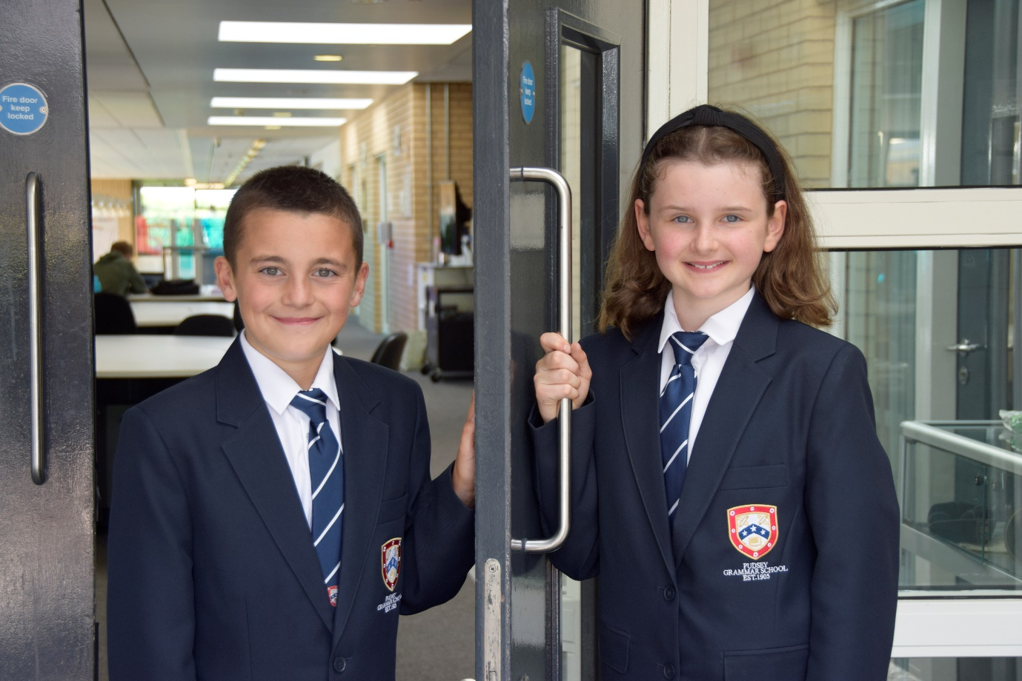

**TEACHER OF**

**ENGLISH**

**APPLICATION PACK**

**Associate Teacher - Permanent**

**C1 (£27,711 - £30,060)**

**Actual salary (£23,843 - £25,854)**

**37 hours per week term time only plus 5 days**

**Working pattern:**

**8.00am – 4.15 pm Monday to Thursday**

**8.00am – 2.30pm Fridays**

**Start Date: As soon as possible**

Contents

1. Introduction from the Headteacher
2. Information on the post
3. Job description
4. Person specification
5. Enhanced disclosure
6. School Location and Travel Information

**Introduction from the Headteacher**

Thank you for the interest you have shown in the post of Associate Teacher at our school. This is an excellent opportunity to join our dynamic Student Support Team.

Pudsey Grammar School is a heavily oversubscribed mixed comprehensive secondary school located in the heart of the market town of Pudsey. Situated between Leeds and Bradford the town has always valued its independence from its two larger neighbours. The school has a long and proud history stretching back to 1905. The school has 1350 students with a thriving and expanding Sixth Form of over 250 students all taught in a state-of-the-art building. The innovative and unique style of the building creates a calm atmosphere very different to many secondary schools.

I was appointed in 2014 and since then we have received a letter from Amanda Spielman (HMCI Ofsted) which stated we ‘have transformed all aspects of the school.’ This assertion was further underlined in 2018 when the increase in our exam results resulted in the school being the most improved school in Leeds and one of the most improved in the country (we were delighted to follow these achievements up with our best ever GCSE exam results in 2019 which were above the national average). The pattern of improvement continued in 2020 with our Year 11 students achieving grades, which were outstanding. The school had a highly successful Ofsted inspection in April 2019 and was judged as good in all areas including our sixth form. The school underwent an ungraded inspection in April 2024 which saw, for the first time in the school’s history, a second successive Ofsted judgement of being a good school. This is testament to the consistently high quality of education which the school provides for all of our students and is one of the reasons why we remain one of the most popular schools across the city of Leeds with over 900 applications received for 215 Year 7 places for September 2024.

In 2022, the school was selected to be a national Behaviour Hub school. This was a Department for Education programme led by the Governments’ School Behaviour Advisor, Tom Bennett, which identifies schools who have ‘an exemplary behaviour culture’. We were one of only 20 secondary schools out of 4000 who have achieved this prestigious accolade, and we worked with other schools across the north of England to improve their behaviour cultures.

We have a comprehensive House system which runs across all year groups with over 30 diverse competitions across the year for students and one each half term for staff too. House assemblies take place once every three weeks lead by our eight House Leaders. At the end of each academic year, the winning House is awarded our 80-year-old Victor Ludorum Cup.

We are aiming to be a centre of excellence and every indicator we have; we are on track to achieve this goal. Continuing to recruit high calibre staff is a key priority of our strategy.

The following quotes are taken from the latest Ofsted report:

* *The school is welcoming and pupils respect the differences in other people.*
* *Safeguarding is very well led, and pupils feel safe*
* *Pupils get on very well with each other*
* *Teachers have strong subject knowledge*
* *Pupils behave well in lessons and the vast majority focus on their work*
* *The school has developed an ambitious curriculum for pupils*
* *Staff have high expectations of all pupils. The vast majority of pupils rise to these expectations and work hard*
* *Pupils benefit from the curriculum and are well prepared for their next steps*
* *The House system plays a central role in the school and provides a sense of belonging. Pupils who earn House ties for their dedication to House competitions wear them with pride*
* *If bullying happens, pupils are confident that staff will deal with it quickly*

The school has a long tradition in the town, being established as Pudsey Grammar School in 1905. Although the school is taught in a state-of-the-art building, our core values of respect, resilience, integrity, compassion and ambition are highly traditional and are based on the goal of ensuring that every student reaches their true potential.

Our school is not just about the student’s gaining knowledge and qualifications, although these are extremely important. We believe in teaching young people core values of decency, social skills and how to be a good citizen in an ever-changing world. We want their character to develop and grow and for them to leave us with an inquiring and independent mind. We want our students to gain the best qualifications they are capable of whilst experiencing a range of opportunities which are second to none. As a result, the school is extremely popular with our community and is significantly over-subscribed every year.

Our Sixth Form, which is rated as good by Ofsted, has grown in recent years and we now have over 250 post-16 students studying at Pudsey Grammar. We have a strong tradition of ensuring students access the best universities including Oxford and Cambridge.

Our staff show exceptional dedication and commitment to our students. Relationships in the school are extremely strong and this underpins the ethos of the school. We pride ourselves in the care and support that we give our staff and as a result there is a real team spirit in the school where people enjoy being part of

our school community. Teaching and learning is the key focus of the organisation and everything that we do is designed to ensure that the classroom experience for the students is excellent. We are currently redesigning our curriculum to ensure that the education we offer is second to none.

We offer fantastic support and professional development to staff which ensures that everyone is equipped with all the necessary skills to be an excellent practitioner and deliver a first-class education to all students.

The school is a foundation Trust school, and our partners include global companies such as Asda, HSBC bank alongside leading local business and training provider, Appris. These high-quality links allow our school to offer excellent careers

opportunities to students across the ability range. As a result, the school has 0% NEETs at Year 11.

We are currently part of The Leeds Teaching Hubs, which is providing outstanding opportunities and CPD for all of our staff. Subject Leaders attend their Collaborative Learning Groups, which allows them to network and share best practice. This is further disseminated through the school via regular department meetings and weekly Teaching & Learning briefings.

This clearly is an exciting time to join our school.

If you have a desire to work in one of the most exciting and rewarding schools, which will also provide you with excellent development opportunities, please complete the application form. Any further details can be obtained directly from the school’s HR Team: [recruitment@pudseygrammar.co.uk](mailto:recruitment@pudseygrammar.co.uk) or visit our website [www.pudseygrammar.co.uk](http://www.pudseygrangefield.co.uk)

**Mark McKelvie**

**Headteacher**

**Pudsey Grammar School**

**Details of advert**

**Job Title: Associate Teacher - Permanent**

**Hours and working pattern: 37hpw, plus 5-day training days (8.00am-4.15pm Monday to Thursday and 8.00am to 2.30pm Fridays)**

**Grade: C1, 12 - 17**

**Salary: £27,711 - £30,060 FTE (£23,843 - £25,854 Actual)**

**Start date: ASAP**

We are seeking an enthusiastic, dedicated, and compassionate Associate Teacher to join our committed, hard-working and dynamic staff team. This position offers an exciting opportunity for individuals who are passionate about education and eager to contribute to the academic and personal development of students and would particularly suit someone who is thinking about a career in teaching.

As an Associate Teacher, you will support the classroom teacher in delivering high-quality lessons, providing targeted interventions, and assisting with the overall management of the classroom. You will work closely with students, helping them to engage with the curriculum and achieve their full potential in a supportive and inclusive learning environment. You will also be required to supervise lessons using work and resources provided during the short-term absence of teaching colleagues.

Having been a lead school in the DfE’s Behaviour Hub programme, you will be supported to achieve good behaviour and classroom management by a team of experienced and dedicated teaching staff and middle leaders. You will have the opportunity to be linked to a curriculum department and involved with the development of a subject specialism under the guidance of the Subject Leader.

**Applicants will need to demonstrate:**

* Excellent attention to detail, effective analytical skills and strong interpersonal and communication skills, together with the ability to work as part of a successful team.
* A commitment to supporting students of all abilities, including those with additional learning needs
* A good understanding of young people and behaviour management strategies
* A commitment to:
  + Working in line with statutory safeguarding guidance (e.g. Keeping Children Safe in Education, prevent and our safeguarding and child protection policies)
  + Will have responsibility for receiving and acting upon any reported concerns and ensuring that the Child Protection Policy is implemented and promote best safeguarding practice across the school as part of the Student Support Team.
  + Promoting the safeguarding of all students in the school

**Why work at Pudsey Grammar School?**

* Be a part of our rapidly improving school
* An organisation which has staff wellbeing as its core
* The opportunity to play a key part in the continuing transformation of the school
* The successful candidate will join a dynamic and enthusiastic team of staff who are ensuring our students are successful in every way
* Have the opportunity to work alongside hub-schools in the Yorkshire and Humber region and University College London, with access to high quality Teaching and Learning training, networking events, CPD and national teacher meetings held annually in London.
* Be part of a supportive organisation which prides itself on high standards for staff and students
* Work in an award-winning state of art building

**This school is committed to safeguarding and promoting the welfare of children and expects all staff and volunteers to share this commitment. Appointments will be subject to an enhanced DBS disclosure. If shortlisted, you will be required to disclose relevant information regarding criminal history and an on-line search will be conducted.  This includes only information publicly available on-line.**

**We promote diversity and want a workforce that reflects the population of Leeds.**

**Employment is conditional on confirmation of the right to work in the UK – either as a UK or Irish citizen, under the EU Settlement scheme or having secured any other relevant work visa. If you do not have the right to work in the UK and the role does not meet eligibility for sponsorship, please consider carefully whether you meet the eligibility to apply for this position.**

**Application Process**

Should you wish to apply for this position, please send the following:

* A completed application form.
* Applications should be made electronically in Word or PDF format to [recruitment@pudseygrammar.co.uk](mailto:recruitment@pudseygrammar.co.uk).
* **Please be aware that we do not accept Curriculum Vitaes**.
* In support of your application, you may include a covering letter. This should be in addition to the completed application form.
* Application form and full job description can be found on the school website:
* https://www.pudseygrammar.co.uk/

**Closing date for applications: 16.04.2025 at 8.00am**

**Successful candidates will be contacted directly with details of the interview.**

**Interview date: 08.05.2025**

**Job Description**

|  |  |
| --- | --- |
|  |  |
| Post Title: | Associate Teacher |
|  |  |
| Post Purpose: | The successful candidate will work under the guidance of teaching/senior staff and within an agreed system of supervision, to implement agreed work programmes with individual groups, in or out of the classroom. This could include those requiring detailed and specialist knowledge in particular areas and will involve assisting the teacher in the whole planning cycle and the management/preparation of resources.  Staff may also supervise whole classes occasionally during the short-term absence of teachers, limited to a maximum of 3 consecutive days for any one absence.  The primary focus will be to maintain good order and to keep pupils on task in line with the school’s Behaviour Policy.  Associate Teacher’s will need to respond to questions and generally assist students to undertake set activities. Marking and assessment activities are limited to those where answers are predetermined, and no element of professional judgement is required. |
|  |  |
| Reporting to: | Teaching & Learning Practioner |
|  |  |
| Working time: | 37 hours per week, term time plus 5 days  **8.00am-4.15pm Monday to Thursday and 8.00am to 2.30pm Fridays**  There will be a requirement to attend staff training and departmental meetings as required which may fall outside of the set hours. |
|  |  |
| Salary/Grade: | C1 (£27,711 - £30,060)  Actual salary (£23,843 - £25,854) |
|  |  |
| Main (Core) Duties: | |
|  |  |
| **Main Responsibilities** | * Assist the classroom teacher in the planning and delivery of lessons across various subjects, ensuring all learning activities align with the curriculum. * Support students in small group and one-to-one settings, providing tailored interventions to help with academic progress. * Monitor and track student progress, providing feedback to the teacher and supporting students in achieving their targets. * Help maintain a positive and respectful classroom atmosphere, ensuring all students feel valued and engaged. * Support students in managing their behaviour, promoting positive attitudes towards learning. * Be fully aware of the school's Behaviour Policy, ensuring consistency and adherence to systems and sanctions at all times, ensuring a positive attitude to student behaviour * Establish effective working relationships with staff and students, acting as a role model at all times and setting high expectations of self and others * Help prepare and organize teaching materials and resources. * Participate in staff meetings, professional development sessions, and school events (some of which may fall outside of contracted hours). * Assist in the supervision of students during breaks, lunchtime, and other non-teaching periods. * Encourage students to develop their independence and critical thinking skills. * Be a role model for students, demonstrating professional conduct and strong interpersonal skills * To undertake other duties as required that are commensurate with the post. |
|  |  |
| **General Characteristics** | * To be aware of and comply with policies and procedures relating to child protection, health, safety and security, confidentiality and data protection, reporting concerns to an appropriate person. * To be aware of and support differences and ensure all students have equal access to opportunities to learn and develop. * To contribute to the overall ethos/work/ aims of the school. * To establish constructive relationships and communicate with other agencies/professionals in liaison with the teacher, to support achievement and progress of students. * To ensure promotion and support of Equal Opportunities and Health & Safety. |
|  |  |
| **Manage Own Performance and Development** | * Take responsibility for their own professional development * Participate in appraisals in line with the school performance management process * Share corporate responsibility for the implementation of school policies and practices * Provide a role model to all students through values, morals, presentation and personal conduct. |
|  |  |
| **Safeguarding** | * Promote good practice by encouraging and promoting the Child Protection policies and procedures in school. * Maintain accurate, confidential and up to date records, on all cases of safeguarding and child protection and maintain confidentiality at all times * Work directly with children in need and their families in order to promote, strengthen and develop the potential of parents/carers and their children to prevent children becoming at risk of significant harm.   Attend training courses in order to keep up to date with relevant policies and procedures. |
|  |  |
| Any Special Conditions of Service: No smoking policy | |
|  |  |
| This job description is to assist staff joining Pudsey Grammar School to understand and appreciate the work content of their post and the role they are to play in the organisation.  Whilst every endeavour has been made to outline the main duties and responsibilities of the post, a document such as this does not permit every item to be specified in detail. This job description is not a definitive list of responsibilities but identifies the key components of the role. The post holder will, therefore, be required to undertake other reasonable duties commensurate with the purpose and salary level of this post.  Employees should not refuse to undertake work, which is not specified on this form, but they should record any additional duties they are required to perform, and these will be taken into account when the post is reviewed.  All new appointments of support staff are made subject  to the satisfactory completion of a six-month probationary period. | |
|  | |
| **Statement:**  **This school is committed to safeguarding and promoting the welfare of children and expects all staff and volunteers to share this commitment. Appointments will be subject to an enhanced DBS disclosure. If shortlisted, you will be required to disclose relevant information regarding criminal history and an on-line search will be conducted.  This includes only information publicly available on-line. The employee may be subject to rechecking as required from time to time.**  **All appointments are subject to satisfactory references.**  Pudsey Grammar School is an equal opportunities employer and requires its employees to comply with all current equality policies both in terms of equal opportunity for employment and access to the school’s services.  We promote diversity and want a workforce which reflects the population of Leeds.  Dated: March 2025 | |

**Person Specification**

|  |  |  |
| --- | --- | --- |
| **SKILLS** | **Ess** | **Des** |
| Excellent numeracy/literacy skills | **\*** |  |
| A commitment to supporting students of all abilities, including those with additional learning needs. | **\*** |  |
| Use of other equipment technology – video, photocopier |  | **\*** |
| A passion for education and working with young people |  | **\*** |
| Ability to deal with Behaviour management, remaining calm under pressure | **\*** |  |
| Strong communication skills, with the ability to work collaboratively within a team | **\*** |  |
| Good organisational skills | **\*** |  |
|  |  |  |
| **KNOWLEDGE/QUALIFICAIONS** | **Ess** | **Des** |
| GCSE (minimum grade C or grade 4) or equivalent in English and Math’s. | **\*** |  |
| Degree in Education or related field |  | **\*** |
| Knowledge of current educational trends and practices in secondary education |  | **\*** |
| Experience working with SEN (Special Educational Needs) students |  | **\*** |
| Understanding of classroom roles and responsibilities and your own position within these | **\*** |  |
| A passion for education and working with young people | **\*** |  |
| A commitment to supporting students of all abilities, including those with additional learning needs. | **\*** |  |
|  |  |  |
| **BEHAVIOURAL AND OVER RELATED CHARACTERISTICS** | **Ess** | **Des** |
| Willing to abide by the Council’s Equal Opportunities Policy in the duties of the post, and as an employee of the Council. | **\*** |  |
| To display a responsible and co-operative attitude to working towards the achievement of the school’s aims and objectives | **\*** |  |
| An ability to respect sensitive and confidential work. | **\*** |  |
| Commitment to own personal development and learning. | **\*** |  |
| Able to respond flexibly to meet daily demands of the role, showing independence and being proactive | **\*** |  |
| Able to work collaboratively with the wider Student Support Team | **\*** |  |
| A willingness to become involved in the wider aspects of the school |  | **\*** |
| Willingness to undertake additional training and professional development | **\*** |  |

**Enhanced Disclosure**

Thank you for your interest in this post at Pudsey Grammar School. The post you are applying for involves working with young people. It is therefore exempt from the Rehabilitation of Offenders Act and any offer of employment will be subject to an Enhanced Disclosure.

As this post is exempt from the Rehabilitation of Offenders Act, you must declare any convictions, including pending convictions, cautions, reprimands and warnings which would otherwise be regarded as “spent” under this Act. Further details will be sought prior to the appointment.

An Enhanced Disclosure is carried out by the Criminal Records Bureau and will check criminal records for information on any convictions, cautions, reprimands and warnings held on the Police National Computer and on local Police records.

All information on criminal records provided both by you and within the Enhanced Disclosure will be used, stored and disposed of in confidence and in line with the Criminal Records Bureau Code of Practice of Disclosure Information.

If your application is successful, you will receive further information on how to complete the Enhanced Disclosure.

***We are committed to safeguarding and promoting the welfare of our pupils and expect all staff and volunteers to share this commitment.***

**School Location and Travel Information**

### Pudsey Grammar School

Mount Pleasant Road

Pudsey

Leeds

LS28 7ND

### Tel: 0113 2558277

### [www.pudseygrammar.co.uk](http://www.pudseygrangefield.co.uk)

Instagram/Twitter/Facebook - @PudseyGS

